Name: __________________________________________________ Student ID: ________________

**Section 1. Fill in the blanks [1 mark each]**

1. CPU
2. RAM
3. ROM
4. Peripheral
5. System software
6. Application software
7. _____ Google Chrome is part of this type of software.
8. _____ Turns on and off internal computer circuits.
9. _____ It frees RAM so that it can be used by other programs.
10. _____ Stores the BIOS.
11. _____ Touchscreen
12. _____ Loads the drivers when you connect a USB microphone.
13. _____ Limits the access of files in secondary memory.
14. _____ Translates computer instructions into hardware actions.
15. _____ Stores information and program data that are being executed.

**Section 2: Answer the following questions.**

1. Explain how information is encoded inside a computer, and how this allows it to represent information. [3 marks].

2. Calculate the minimum number of bits required to encode an alphabet of 800 different icons. Show all the steps used to arrive at your answer. [3 marks]

3. List three functions of an operating system. [3 marks]

**Section 3. Complete the following conversions [3 marks each]**

**A) From binary to decimal**

${10001111}_{2}$

**B) From decimal to hexadecimal**

${265}_{1o}$

**Section 4. Read the following case and answer the questions.**

Barbara Smith is a web designer who works as a web developer. She is starting a new project next month, so she is planning to buy a new computer:

* Operating System Windows 10 of 64-bits
* Full HD 1920x1080 IPS screen of 17.3 inches with low power consumption
* Intel i7-8750H @ 2.20 GHz processor
* 9 MB of cache
* 2 MB of ROM
* 8GB of RAM for advanced multitasking
* 1 hard drive with 1TB storage capacity
* Graphics card NVIDIA GeForce 3060
* 1 USB C port
* 1 USB 3.0 port
* HDMI port
* Bluetooth 5.0
* High-definition webcam
* Headphone jack

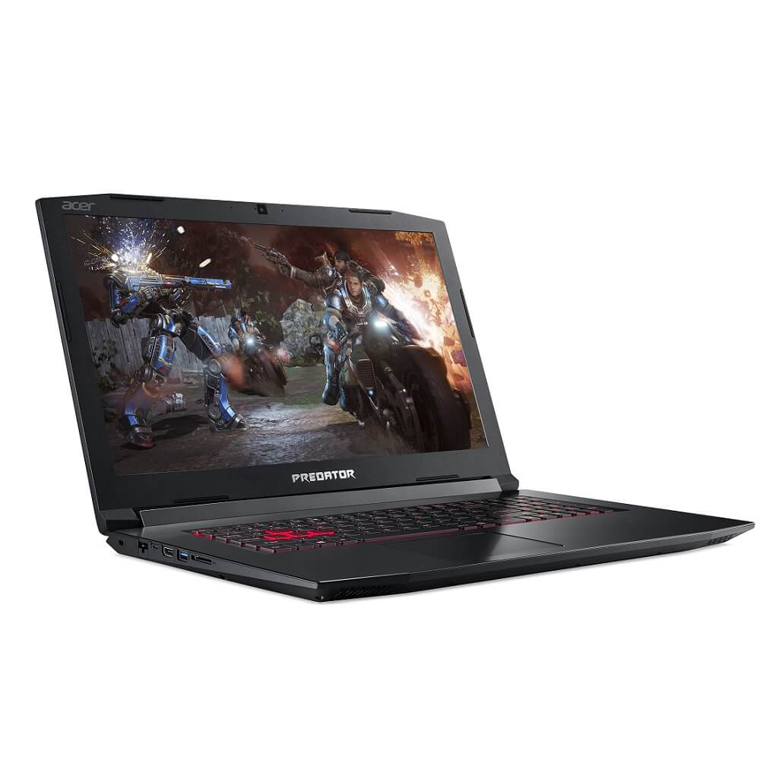

1. Identify the operating system that this computer has [1 mark]
2. Indicate the amount of secondary memory [1 mark]
3. Indicate the amount of main memory [1 mark]
4. Indicate the processor manufacturer [1 mark]
5. Indicate three peripheral devices in this computer [2 marks]